Monday | Tuesday | Wednesday | Thursday | Friday | Saturday | Sunday
845a-930
Strength and Conditioning
 | 7a-8a  Adult/Teens All Level BJJ – Gi |  | 7a-8a  Adult/Teens All Level BJJ – Gi |  | 930a-1030a  Little Sharks and Junior Jiu-Jitsu | 9a-10a  Adult/Teens All Level BJJ - NO Gi
 |  |  |  |  | Women’s Self Defense
12p-1p  Adult/Teens All Level BJJ - NO Gi | 12p-1p  Adult/Teens All Level BJJ - Gi | 12p-1p  Adult/Teens All Level BJJ - NO Gi | 12p-1p  Adult/Teens All Level BJJ - Gi | 12p-1p  Adult/Teens All Level BJJ - NO Gi | 1030a-12p  Adult/Teens All Level BJJ –Gi | 10a-11a  Open Mat
5p-6p  Little Sharks and Junior Jiu-Jitsu | 5p-6p  Little Sharks and Junior Jiu-Jitsu | 5p-6p  Little Sharks and Junior Jiu-Jitsu | 5p-6p  Little Sharks (and Junior Jiu-Jitsu | 5p-6p  Little Sharks and Junior Jiu-Jitsu | 1130a-1230p  Adult/Teens Muay Thai
5p-6p  Adult/Teens All Level BJJ – NO Gi | 5p-6p  Adult/Teens All Level BJJ –Gi | 5p-6p  Adult/Teens All Level BJJ – NO Gi | 5p-6p  Adult/Teens All Level BJJ –Gi | 5p-6p  Adult/Teens All Level BJJ – NO Gi | 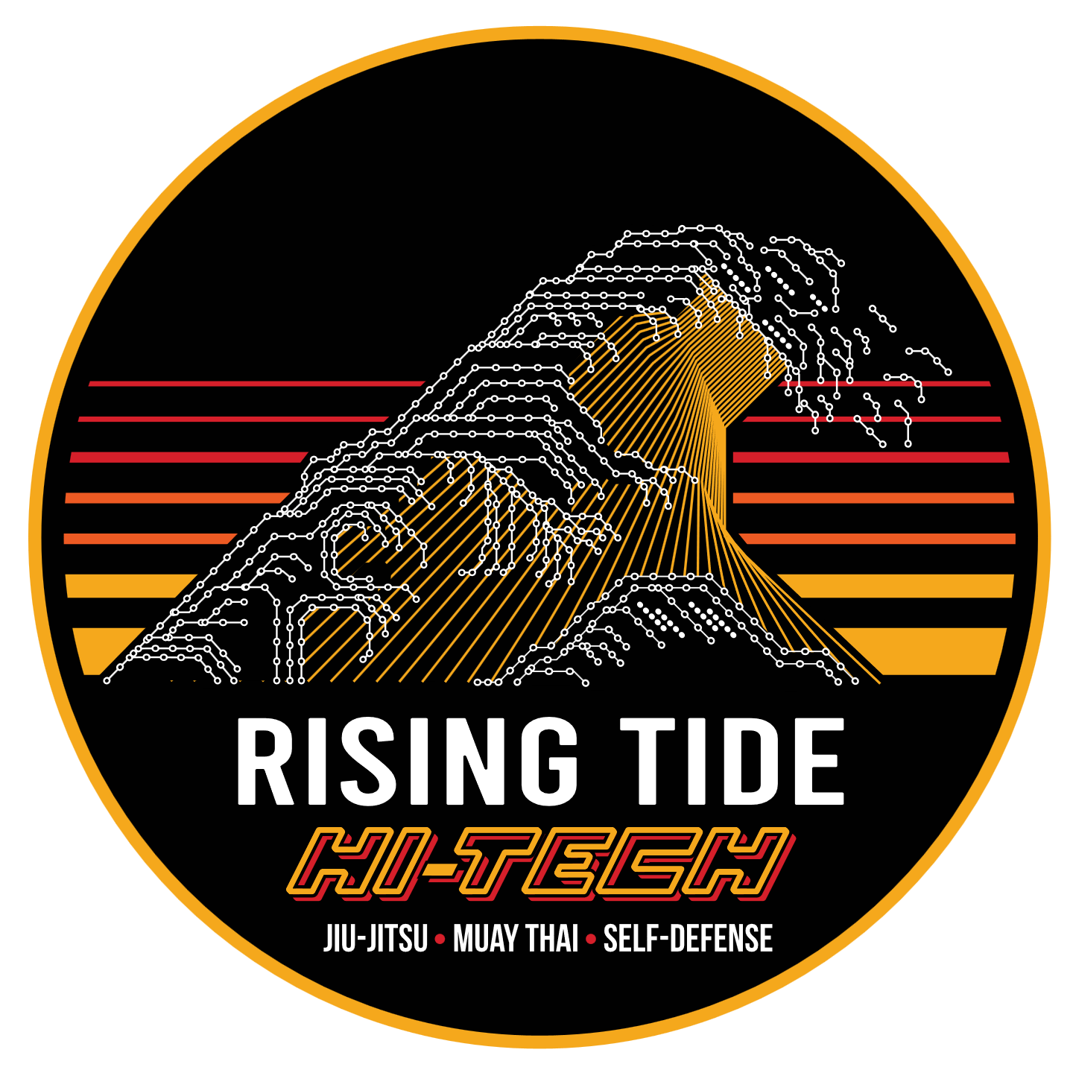  7030 Hi Tech Drive, Hanover, MD 21076  (410) 953-8492
6p-7p  Adult/Teens All Level BJJ – NO Gi | 6p-7p  Adult/Teens All Level BJJ –Gi | 6p-7p  Adult/Teens All Level BJJ – NO Gi | 6p-7p  Adult/Teens All Level BJJ –Gi | 6p-7p  Adult/Teens All Level BJJ – NO Gi
6p-7p  Kid’s Muay Thai | 6p-7p  Kid’s Muay Thai | 6p-7p  Adult/Teens Muay Thai | 6p-7p  Women’s Self Defense | 6p-7p  Kid’s Muay Thai
 | Women’s Self Defense
7p-8p  Adult/Teens Muay Thai | 7p-8p  Adult/Teens Muay Thai | 7p-8p  Adult MMA Class  Alex Romanov | 7p-8p  Adult/Teens Muay Thai | 7p-8p  Adult/Teens Muay Thai

